1. **Create a pipeline:**
   * **Open Data Factory and navigate to Author > Pipelines > New Pipeline.**
   * **Add a Databricks Notebook activity for Notebook 1 and configure it.**

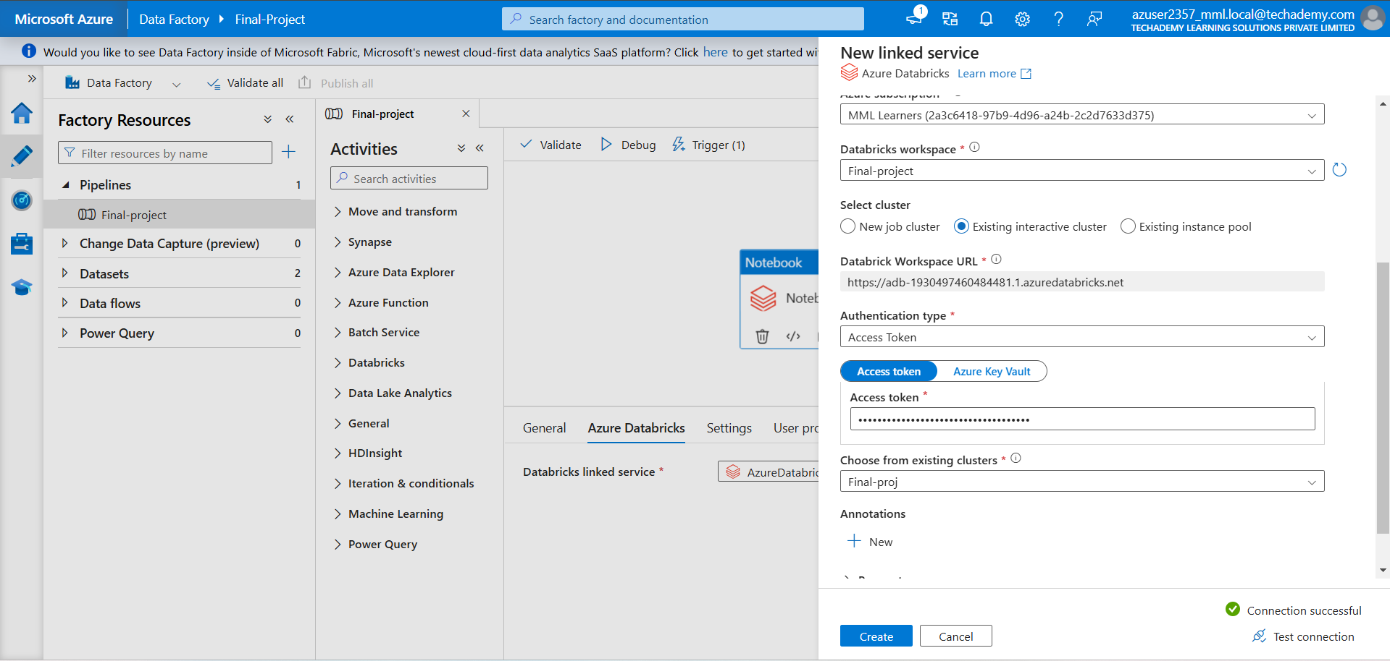

* + **Add another Databricks Notebook activity for Notebook 2 and configure it.**

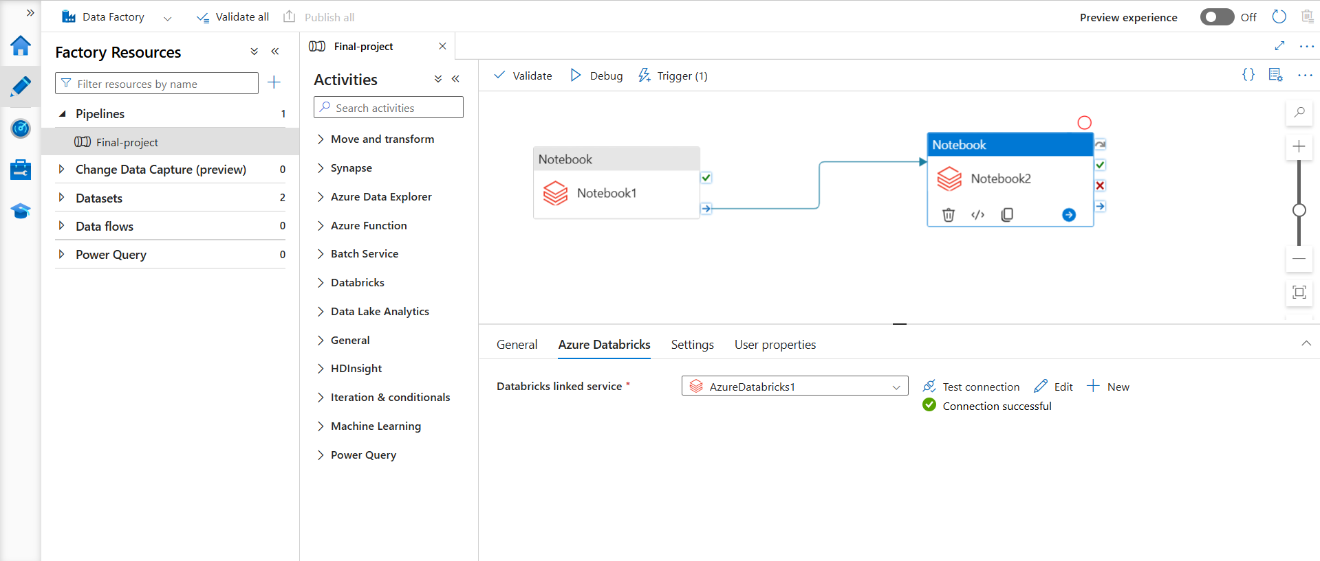

* **Connect the activities to execute Notebook 2 after Notebook 1.**

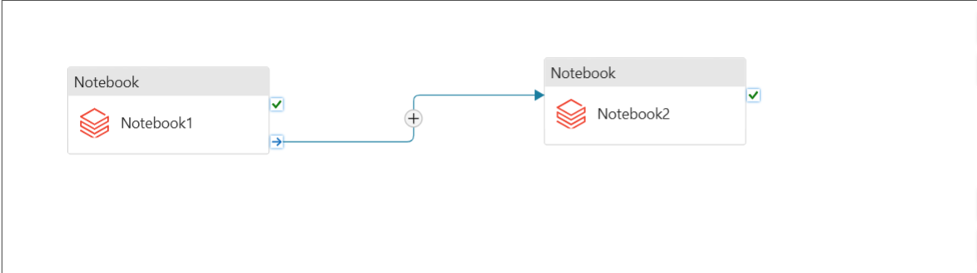

1. **Add a trigger to the pipeline:**
   * **Navigate to the Triggers tab in the pipeline editor.**
   * **Click on Add Trigger > New/Edit.**

